**AUTOMATIC PLANT WATERING MACHINE**

**A report submitted in partial fulfillment of the Academic requirements for the award of the degree of**

**Bachelor of Technology**

P.N.V.J. KIRAN (19H51A05P6)

K. VINAY BHARGAV (19H51A05N5)

K. JAI SANTHOSH BABU (19H51A05N6)

S. HARISH REDDY (19H51A1259)

D.BABU (20H55A0504)

**UNDER THE COURSE**

 **SOCIAL INNOVATION IN PRACTICE**

**CENTRE FOR ENGINEERING EDUCATION RESEARCH**

**CMR COLLEGE OF ENGINEERING & TECHNOLOGY**

**(Autonomous)**

**(NAAC Accredited with ‘A’ Grade & NBA Accredited)**

**(Approved by AICTE, Permanently Affiliated to JNTU Hyderabad)**

**KANDLAKOYA, MEDCHAL ROAD, HYDERABAD-501401**

**2020-2021**

**CENTRE FOR ENGINEERING EDUCATION RESEARCH**

**CMR COLLEGE OF ENGINEERING & TECHNOLOGY**

**(Autonomous)**

**(NAAC Accredited with ‘A’ Grade & NBA Accredited)**

**(Approved by AICTE, Permanently Affiliated to JNTU Hyderabad)**

**KANDLAKOYA, MEDCHAL ROAD, HYDERABAD-501401**



**CERTIFICATE**

This is to certify that the report entitled **“AUTOMATIC PLANT WATERING MACHINE”** is a bonafide work done by **P.N.V.J. KIRAN(19H51A05P6), K VINAY BHARGAV(19H51A05N5),K. JAI SANTHOSH BABU(19H51A05N6), S. HARISH REDDY(19H51A1259), D.BABU (20H55A0504)** of II B.Tech, in partial fulfillment of the requirements for the award of the degree of Bachelor of Technology, submitted to Centre for Engineering Education Research, CMR College of Engineering & Technology, Hyderabad during the Academic Year 2020-2021.

**( Names of the project coordinators) (Mrs.D. Sowjanya)**

1. Mr. B. Suresh Ram Head CEER

2. Mrs. N. Suvarna

**DECLARATION**

We, the students of II B.Tech of Centre for Engineering Education Research , CMR COLLEGE OF ENGINEERING & TECHNOLOGY, Kandlakoya, Hyderabad, hereby declare, that under the supervision of our course coordinators, we have independently carried out the project titled “Automatic plant watering machine” and submitted the report in partial fulfillment of the requirement for the award of Bachelor of Technology in by the Jawaharlal Nehru Technological University, Hyderabad (JNTUH) during the academic year 2020-2021.

**STUDENTNAME ROLL NUMBER SIGNATURE**

P.N.V.J. KIRAN (19H51A05P6)

K VINAY BHARGAV (19H51A05N5)

K. JAI SANTHOSH BABU (19H51A05N6)

S. HARISH REDDY (19H51A1259)

D.BABU (20H55A0504)

**ACKNOWLEDGEMENT**

We are obliged and grateful to thank Mrs.D.Sowjanya, Head(CEER), CMRCET, for his cooperation in all respects during the course.

We would like to thank the Principal of CMRCET, Dr.V.A.Narayana, for his support in the course of this project work.

Finally, we thank all our faculty members and Lab Assistants for their valid support.

We own all our success to our beloved parents, whose vision, love and inspiration has made us reach out for these glories.

### ABSTRACT

Watering is the most important cultural practice and most labor intensive task in daily greenhouse operation. Watering systems ease the burden of getting water to plants when they need it. Knowing when and how much to water is two important aspects of watering process. To make the gardener works easily, the automatic plant watering system is created. There have a various type using automatic watering system that are by using sprinkler system, tube, nozzles and other.

This system uses Arduino UNO board, which consists of ATmega328 microcontroller. It is programmed in such a way that it will sense the moisture level of the plants and supply the water if required. This type of system is often used for general plant care, as part of caring for small and large gardens. Normally, the plants need to be watered twice daily, morning and evening. So, the microcontroller has to be coded to water the plants in the greenhouse about two times per day. However for most people it becomes challenging to keep them healthy and alive. This system automation is designed to be assistive for the University Park. This system hopes that through this prototype people will enjoy having plants without the challenges related to absent or forgetfulness.

**TABLE OF CONTENTS**

|  |  |  |  |
| --- | --- | --- | --- |
| **CHAPTERS** | | **DESCRIPTION** | **PAGE No** |
|  |  | Abstract |  |
| 1 |  | Introduction | 1 |
| 2 |  | Literature Review | 2 - 5 |
| 3 |  | Problem Definition |  |
|  | 3.1 | Community interaction with  the concerned project team | 7 - 8 |
|  | 3.2 | Problem Statement | 9 |
|  | 3.3 | Objective | 9 |
|  | 3.4 | Requirement Analysis | 9-18 |
|  | 3.5 | Methodology | 19 |
| 4 | 4.1 | Conceptual Design | 19– 22 |
|  | 4.2 | Block Diagram | 23 |
|  | 4.3 | Design Description | 24 |
| 5 |  | Implementation | 25 |
|  | 5.1 | Results and Discussions | 26 |
|  | 5.2 | Conclusions | 26 |
| 6 | 6.1 | Appendix | 27 |
|  | 6.2 | References | 27 |

**1.INTRODUCTION:**

Arduino is an open-source electronics electronic platform based on easy-to-use hardware and software. Arduino boards are able to read inputs- light of sensor, a finger on a button, or a Twitter messages,- and turn it into an output- activating on a motor, turning on an LED, publishing something online.

Over the years Arduino has been the brain of thousands of projects, from everyday objects to complex scientific instruments.

A worldwide community of markers has gathered around this open-source platform, their contributions have add to up an incredible amount of accessible knowledge that can be of great help to novices and experts alike.

Arduino was born at the Lvrea Interaction Design Institute as an easy tool for fast prototyping, aimed at students without a background in electronics and programming.

As soon as it reached a wider community, the Arduino board started changing to adapt to new needs and challenges, differentiating its offer from simple 8-bit boards to products for IoT application, wearable, 3D printing, and embedded environments.

**2.LITERATURE REVIEW:**

**2.1. Existing Solutions:**

**1.Manual Work:**

We normally water the plants manually using manpower. Sometimes, we water the plants without ensuring whether the plant requires the water or not. Then plants may get more water than required which leads to difficulty in taking co2 by the roots. So, to avoid such problems we need a tool that helps to water the plants.

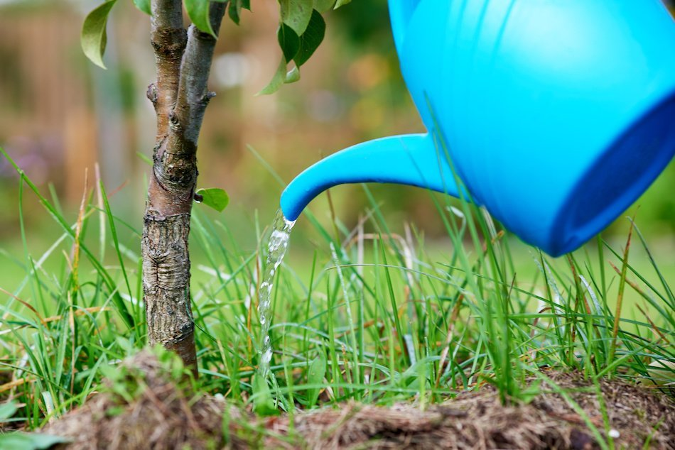

MANUAL WATERING

**2.Fully Automatic Plant Watering System:**

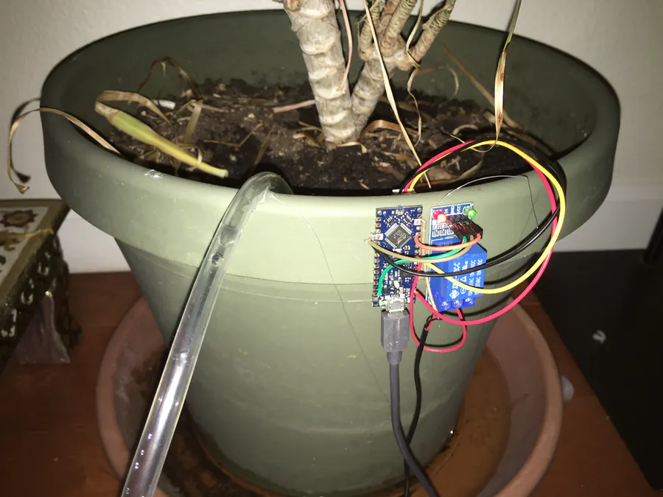

The pump delivers water from your container into your plant. You may have to refill your container every once in a while. The relay is used to trigger the pump. The soil moisture sensor detects the amount of water in the soil. The tube is used to take water from the pump's outlet onto the plant.

Insert the soil moisture sensor into the soil near your plant. If your plant is outdoors, you have to protect your electronics from getting rusted or damaged. To avoid corrosion of the soil moisture sensor, you a capacitive one. Glue or tape the relay module and the arduino to a nearby wall. In my case, I glued it to the pot which had my plant in it. Place the water container in an accessible place. It should be close enough to the arduino and relay so the wires can connect to it and also should be easily to refill. Fill the container with water. Put the pump in the water with the inlet facing down. Attach the tube to the outlet and put it facing the plant.

**3.Automated Plant Watering System**

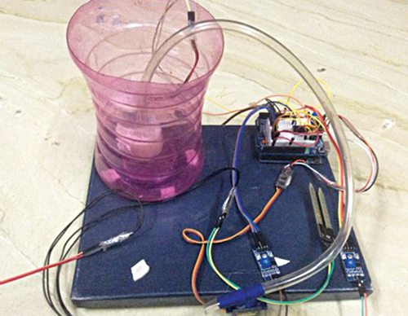

During summers, most people are too lazy to water the potted plants on their rooftop gardens every day. Explained in this section is a simple and exciting automatic plant watering system that you can build yourself in just a few hours. It is an Arduino based automatic plant watering system that uses a soil moisture sensor.

The circuit diagram of the automatic plant watering system is shown in Fig. 2. The circuit comprises an Arduino UNO board, a soil moisture sensor, a servo motor, a 12V water pump and an L293D (IC1) motor driver IC to run the water pump.

You can power the Arduino board using a 7V to 12V wall wart or plug-in adaptor or solar panel. You need a separate 12V battery or power supply or solar panel for the pump motor.

**4.An Urban Plant Watering Solution**

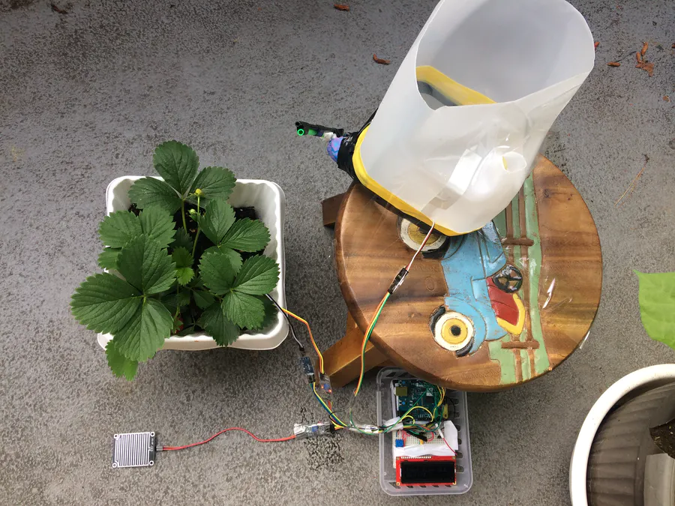

This device improves plant irrigation in urban environments. Powered by an Arduino 101, it uses on-board tools along with a few external sensors to calculate optimum conditions for watering plants in its own environment, and then waters the plant itself at the calculated time.

This solution is designed to make urban plant irrigation simpler and more optimized by employing an automatic setup to take care of this. It also conserves rainwater along with existing house supplies by using a reservoir, which puts rain not directed at the plants to good use.

**GAPS IN EXISTING SOLUTIONS:**

All the existing solutions have many disadvantages. Thefollowing are the gaps we found in those existing solutions:

* Manually watering a huge bunch of plants will consume lots of time.
* Watering plants time to time may lead to difficulty in taking co2 from roots .
* When the watering system supplies the water time to time , and suddenly there is rain fall it will make the soil more wet and leads to death.
* They are expensive.
* They have given connection to water only one plant.

**5. Proposed Solution:**

As we have gone with the need statement, we gone through a literature review so that we can know what exactly our prototype must contain, what kind of updates it should have. While going through this process we came across constraints like :

1.It should be less cost.

2.No humans interaction is required.

3. we can prevent the death of plants.

4. Easily used by humans and plant nursery’s .

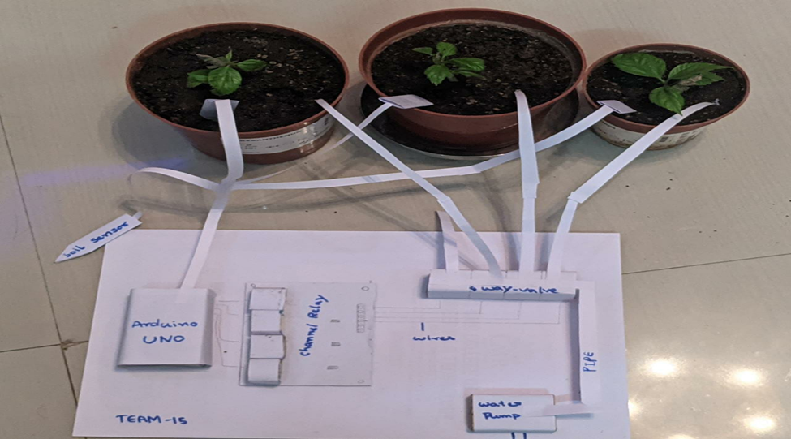

**3.PROBLEM DEFINITION:**

**3.1. Community interaction with the concerned project team:**

On behalf of community visit, we have visited a plant nursery near to our college. There we have identified many problems like sanitation problems, mosquitoes, security problems, no proper streetlights, watering plants problem faced by the people while watering the plants etc., Out of all these problems we have decided and chose to make a automatic plant watering machine.

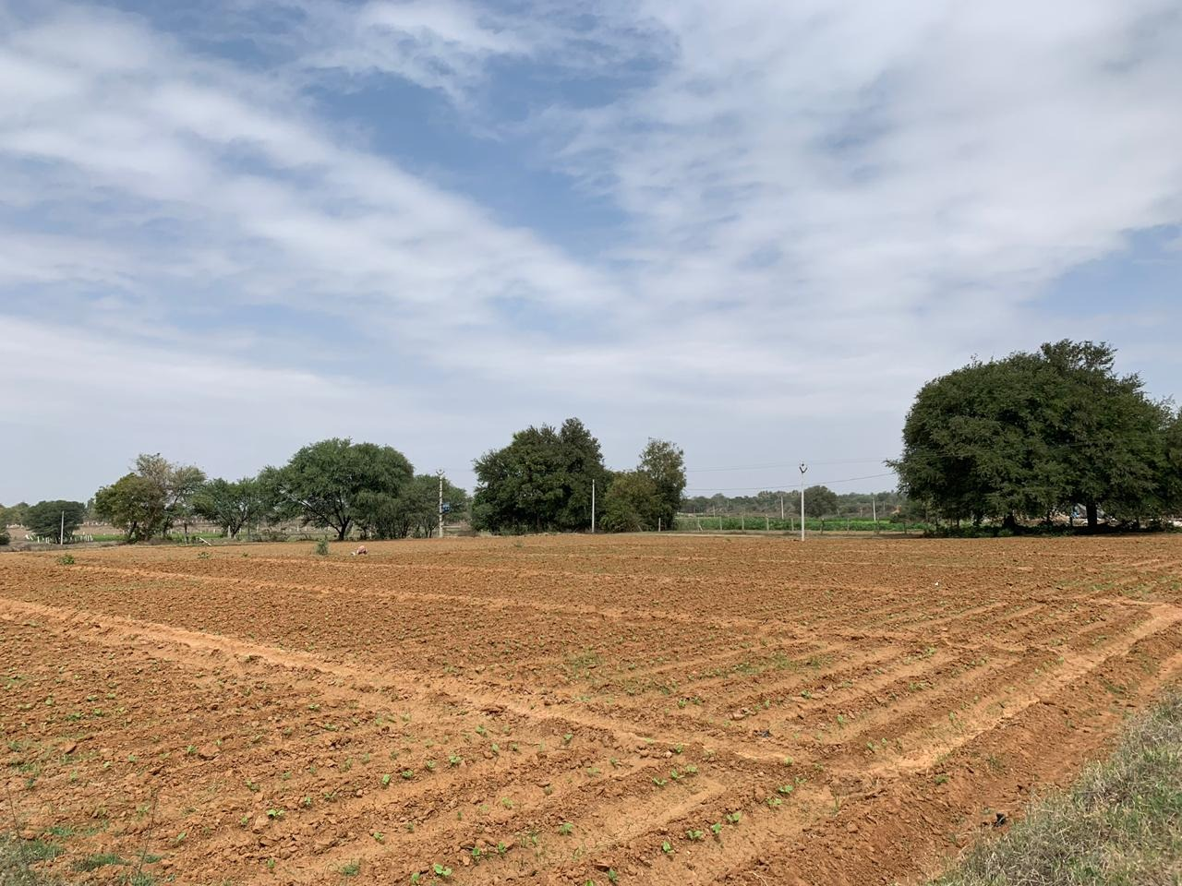

COMMUNITY VISIT

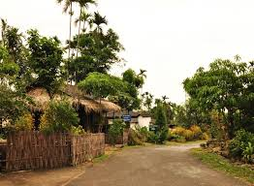



**3.2 .Problem Statement:**

Watering plants daily is compulsory. At the same time water should not be wasted. Now a days we are so busy that we forget to water plants. So the idea behind this is, the project will be used to water plants time to time which leads to healthy growth of plants, prevents over watering as well as wastage of water.

**3.3 Objective:**

1. to easily water plants and plant nursery.

2. To exclude human interference.

3. It should be easy to use.

4.To stop the death of plants.

**3.4.Requirement Analysis:**

1. ARDUINO UNO:

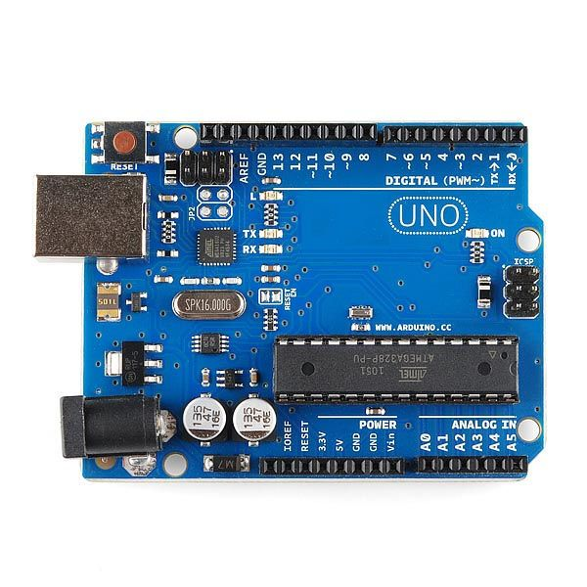

ARDUINO UNO

**Arduino Uno** is a microcontroller board based on the ATmega328P ([datasheet](http://ww1.microchip.com/downloads/en/DeviceDoc/Atmel-7810-Automotive-Microcontrollers-ATmega328P_Datasheet.pdf)). It has 14 digital input/output pins (of which 6 can be used as PWM outputs), 6 analog inputs, a 16 MHz ceramic resonator (CSTCE16M0V53-R0), a USB connection, a power jack, an ICSP header and a reset button. It contains everything needed to support the microcontroller; simply connect it to a computer with a USB cable or power it with a AC-to-DC adapter or battery to get started.. You can tinker with your Uno without worrying too much about doing something wrong, worst case scenario you can replace the chip for a few dollars and start over again.

"Uno" means one in Italian and was chosen to mark the release of Arduino Software (IDE) 1.0. The Uno board and version 1.0 of Arduino Software (IDE) were the reference versions of Arduino, now evolved to newer releases. The Uno board is the first in a series of USB Arduino boards, and the reference model for the Arduino platform; for an extensive list of current, past or outdated boards see the Arduino index of boards.

2. SOIL MOISTURE SENSOR :

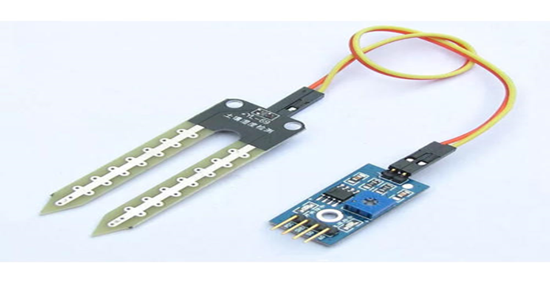

SOIL MOISTURE SENSOR

The soil moisture sensor is a device to measure volumetric water content in the soil. The sensor measures volumetric water content indirectly, without removing moisture, by using other parameters of soil like electrical resistance or conductance, dielectric constant and interaction with other neutrons. The result may vary depending on environmental factors like soil type, temperature, and conductivity, so it must be calibrated.

The sensor includes a potentiometer to set the desired moisture threshold. When the sensor measures more moisture than the set threshold, the digital output goes high and an LED indicates the output. When the moisture in the soil is less thatn the set threshold, the output remains low. The digital output can be connected to a micro controller to sense the moisture level. The sensor also outputs an analog output which can be connected to the ADC of a micro controller to get the exact moisture level in the soild.



3. 5V POWER SUPPLY MODULE :

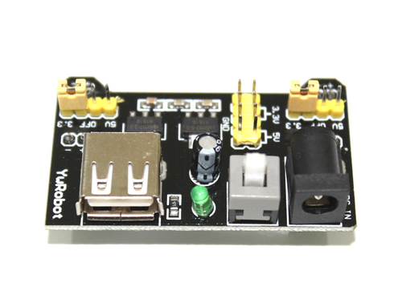

5V POWER SUPPLY

The Breadboard power supply has 3.3V/5V selectable output on two channels. The maximum current can be drawn is 700mA. The selection of the output voltage is independent on each channel and the user can select the output voltage by changing jumpers separately.At the input section, a DC barrel socket and USB-A socket is available. Anyone of these two can be used to power up the module. There is an ON-OFF switch available along with a power-on status LED. Use a 6.5-12VDC power supply for powering up the module.

Jumper pins are utilized for selecting the voltage levels on each side of the breadboard power rails. You can choose between 5 V, OFF, and 3.3 V. There are two sets of jumper selectors for each side of the breadboard power rails; hence, you can have any combination of voltages on either rail. There are also header pins for tapping off voltages, using a cable or jumper wires.  
  
The AMS1117 is a voltage regulator manufactured by Advanced Monolithic Systems. There are two regulators where one regulator establishes a 3.3 V rail, whilst another establishes the 5 V rail. These are a good make of components found in a SOT-223 package. Their documentation states that this series can provide a maximum output current of 1 A, and the absolute maximum input voltage rating is 15 V.

4.BEARDBOARD :

A **breadboard** is a construction base for prototyping of electronics Originally the word referred to a literal bread board, a polished piece of wood used for slicing bread. In the 1970s the **solderless breadboard** (a.k.a. **plugboard**, a terminal array board) became available and nowadays the term "breadboard" is commonly used to refer to these.

4. SOLENOID VALVES :

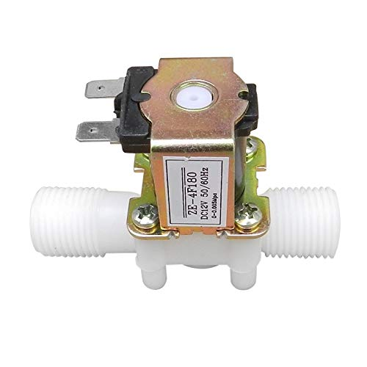

SOLENOID VALVE

Solenoid valves differ in the characteristics of the electric current  they use, the strength of the  magnetic field they generate, the mechanism they use to regulate the fluid, and the type and characteristics of fluid they control. The mechanism varies from linear action, plunger-type actuators to pivoted-armature actuators and rocker actuators. The valve can use a two-port design to regulate a flow or use a three or more port design to switch flows between ports. Multiple solenoid valves can be placed together on a manifold.

Solenoid valves are the most frequently used control elements in  fluidics. Their tasks are to shut off, release, dose, distribute or mix fluids. They are found in many application areas. Solenoids offer fast and safe switching, high-reliability, long service life, good medium compatibility of the materials used, low control power and compact design.

5. WATER PUMP (SUBMERSIBLE):

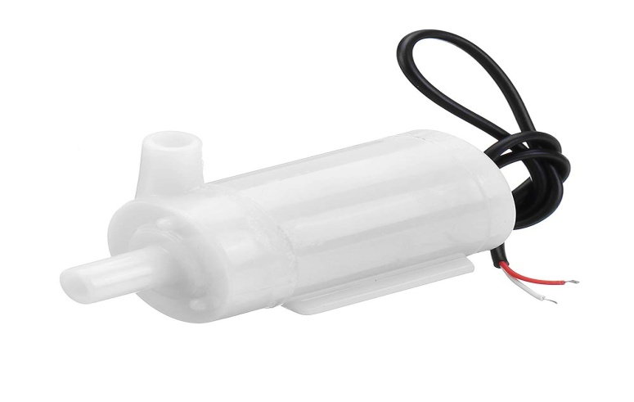

WATER PUMP

The working principle of a water pump mainly depends upon the positive displacement principle as well as kinetic energy to push the water. These pumps use AC power  otherwise DC power for energizing  the motor of the water pump whereas others can be energized other kinds of drivers like gasoline engines otherwise diesel.

The water pump is a portable device and can be applied in several household applications. These pumps are used for pumping the huge amount of water from one place to another. The main purpose of a water pump is versatile. A quality pump which can be selected carefully may be perfect for draining water from a low flooded region, refilling the swimming pool, and bathtub, circulating pesticides otherwise fertilizers.

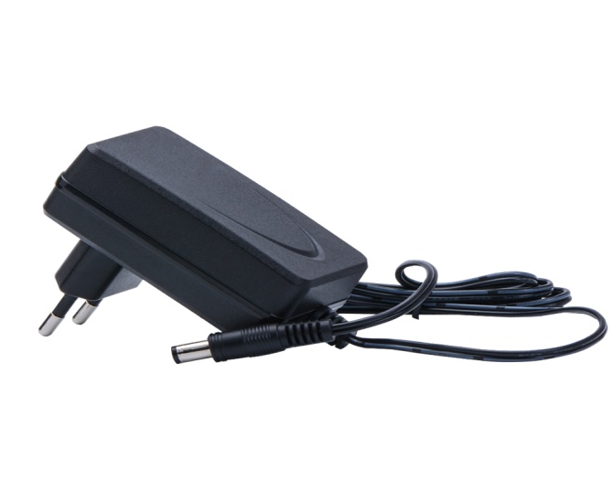6. ADAPTER:

AC ADAPTER

An  AC adapter,  AC/DC adapter, orAC/DC converter is a type of external power supply, often enclosed in a case similar to an  AC plug. Other common names include  plug pack, plug-in adapter , adapter block, domestic mains adapter, line power adapter, wall wart, power brick and power adapter. Adapters for battery-powered equipment may be described as  chargers  or  rechargers . AC adapters are used with electrical devices that require  power  but do not contain internal components  to derive the required voltage and power from mains power. The internal circuitry of an external power supply is very similar to the design that would be used for a built-in or internal supply.

7.JUMPER WIRES:

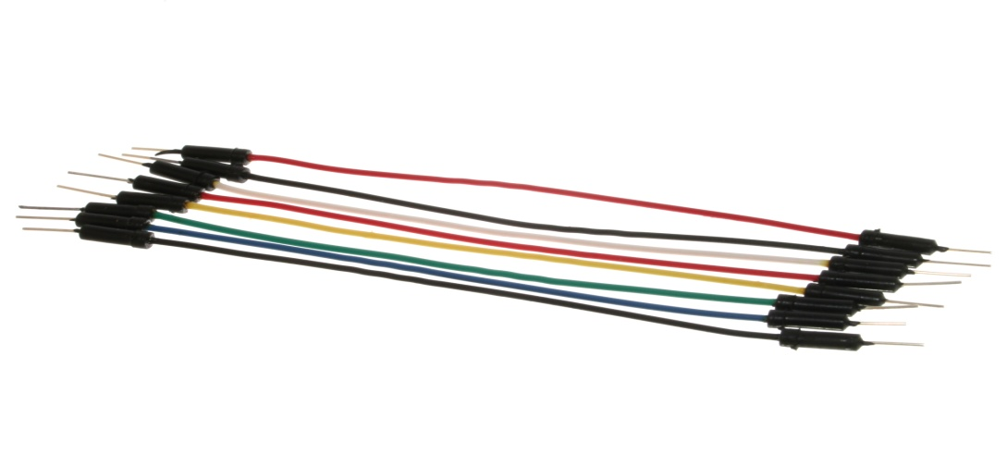

JUMPER WIRES

A **jump wire** (also known as jumper wire, or jumper) is an  electrical wire, or group of them in a cable, with a connector or pin at each end (or sometimes without them – simply "tinned"), which is normally used to interconnect the components of a breadboard or other prototype or test circuit, internally or with other equipment or components, without soldering. Individual jump wires are fitted by inserting their "end connectors" into the slots provided in a breadboard, the  header connector of a circuit board, or a piece of test equipment.

8. 4 CHANNEL RELAY MODULE :

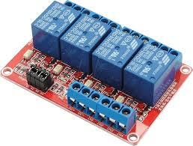

4 CHANNEL RELAY

It is 4 Channel Isolated 5V 10A Relay Module, A wide range of microcontrollers such as Arduino, AVR, PIC, ARM and so on can control it. It is also able to control various appliances and other types of equipment with large current. Relay output maximum contact is AC250V 10A and DC5V 10A. One can connect a microcontroller with standard interface directly to it. Red working status indicator lights are conducive to the safe use. It has a wide range of applications such as all MCU control, industrial sector, PLC control, smart home control. This neat relay module features 4 x 5V relays rated at 10A/250V each. It is designed to switch up to 4 high current (10A) or high voltage (250V) loads with the help of microcontroller.

9.SWITCH MODE POWER SUPPLY:

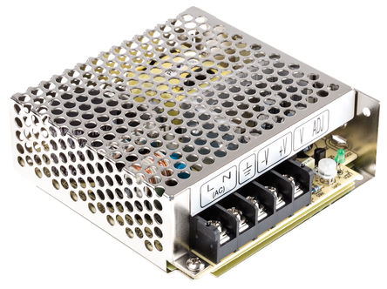

SWITCH MODE POWER SUPPLY

A switch mode power supply (SMPS) is a type of power supply that uses semiconductor switching techniques, rather than standard linear methods to provide the required output voltage. The basic switching converter consists of a power switching stage and a control circuit. The power switching stage performs the power conversion from the circuits input voltage, VIN to its output voltage, VOUT which includes output filtering. The major advantage of the switch mode power supply is its higher efficiency, compared to standard linear regulators, and this is achieved by internally switching a transistor (or power MOSFET) between its “ON” state (saturated) and its “OFF” state (cut-off), both of which produces lower power dissipation. This means that when the switching transistor is fully “ON” and conducting current, the voltage drop across it is at its minimal value, and when the transistor is fully “OFF” there is no current flow through it. So the transistor is acting like an ideal switch.

As a result, unlike linear regulators which only offer step-down voltage regulation, a switch mode power supply, can offer step-down, step-up and negation of the input voltage using one or more of the three basic switch mode circuit topologies: *Buck*, *Boost* and *Buck-Boost*. This refers to how the transistor switch, inductor, and smoothing capacitor are connected within the basic circuit.

**3.5 METHODOLOGY:**

Our problem is to design aautomatic plant watering machine which can be used to water the plants automatically. We designed a modal such that it can be according to our convenience i.e., if we want to water plant, we use our automatic plant watering machine .

**4.1 CONCEPTUAL DESIGN:**

Our design includes very simple mechanism.The design of the prototype is as shown below in the figure

**FOR DETECTING MOISTURE IN THE SOIL:**

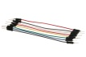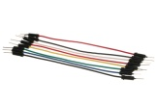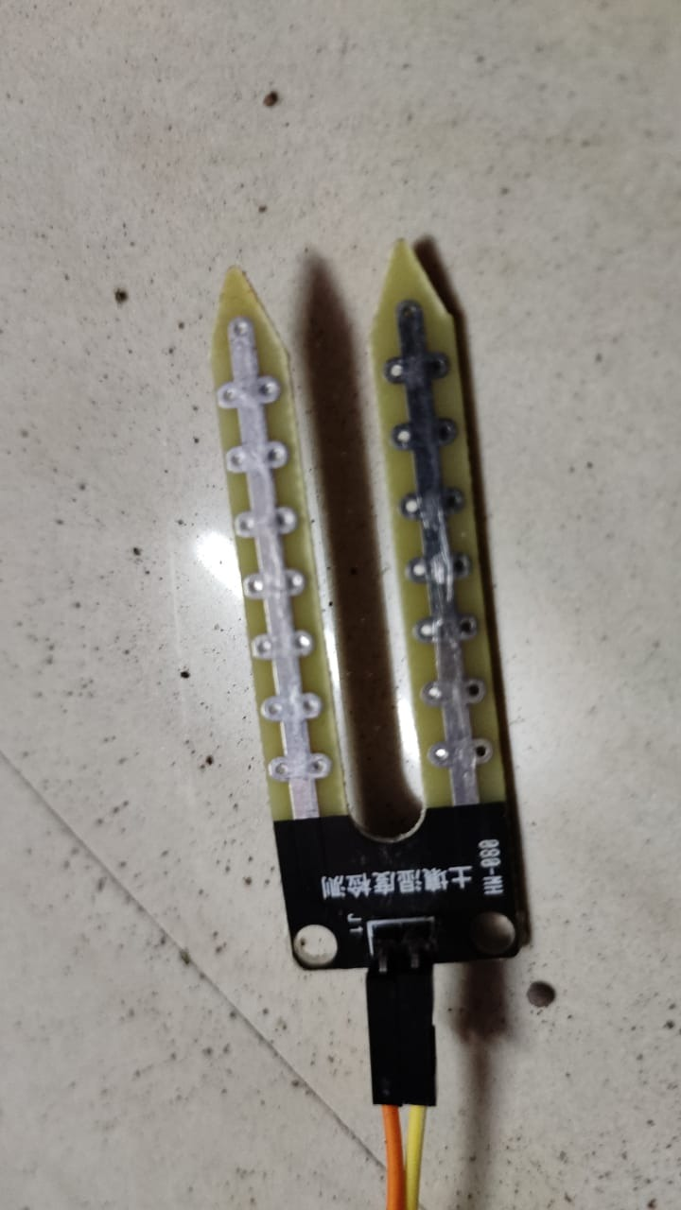

MOISTURE SENSOR

Here , we used relay module to control the electicity and give signals to the solenoid valve to open the valve to allow the water for plants. we can water the plant according to how many raley modules available.

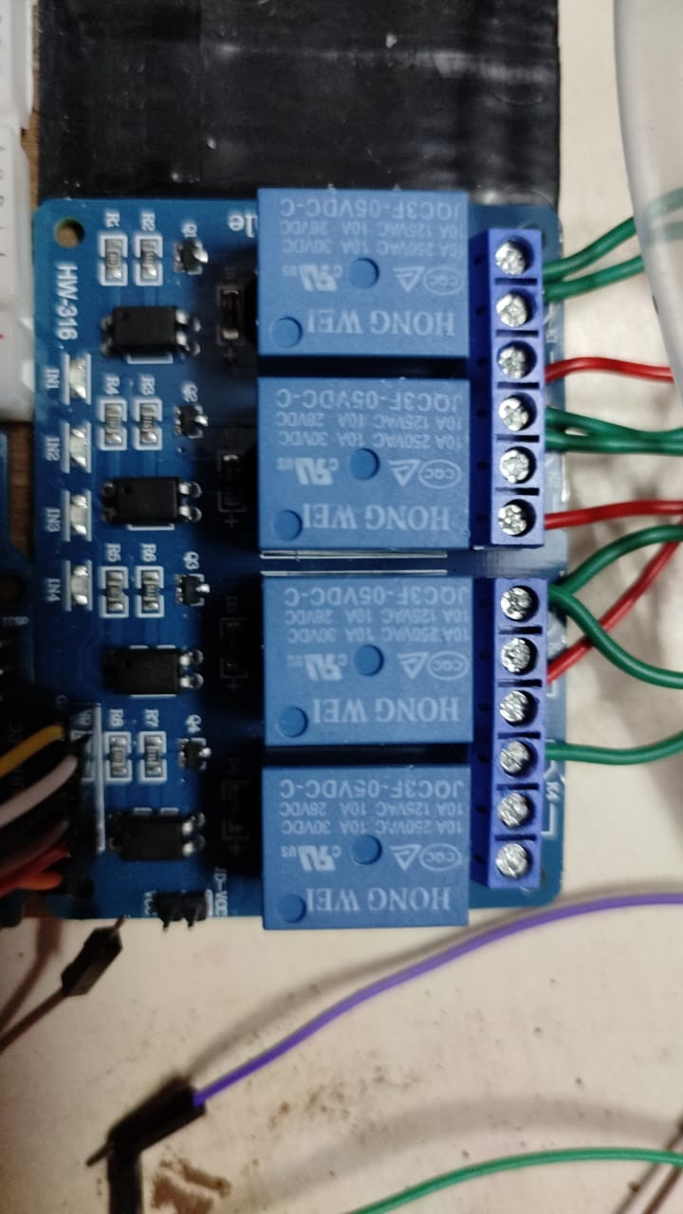

4 CHANNEL RELAY MODULE

**FOR CONTROLLING FLOW OF WATER TO PLANTS:**

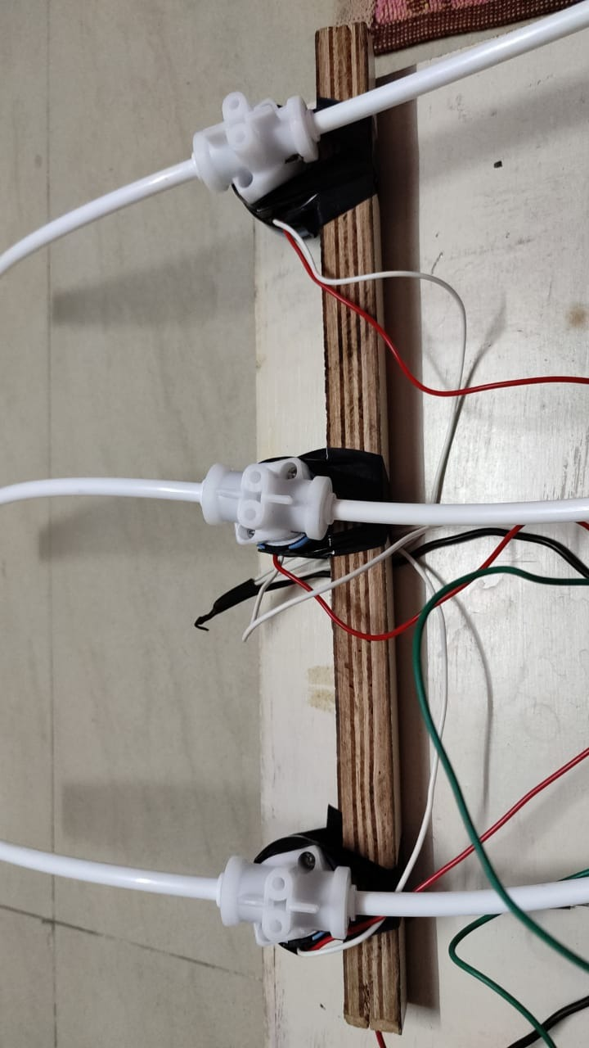

SOLENOID VALVE

Here , we used solenoid valve to control the water flow . When the moisture sensor gives the input to aurdino ,Aurdino will give signals to relay module for controlling the valves and water pump to allow the water through pipe. According to the given input by the relay module the solenoid valve will open the valve and allow the water to flow through the water.

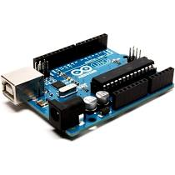

AURDINO UNO

We use aurdino to give signals to relay module , water pump . when moisture sensor gives input to the aurdino ,aurdino will give signal to water pump to allow the water to run the water in pipe and gives signal to relay module to open certain valve to according the given input by soil sensor.

**4.2 BLOCK DIAGRAM:**

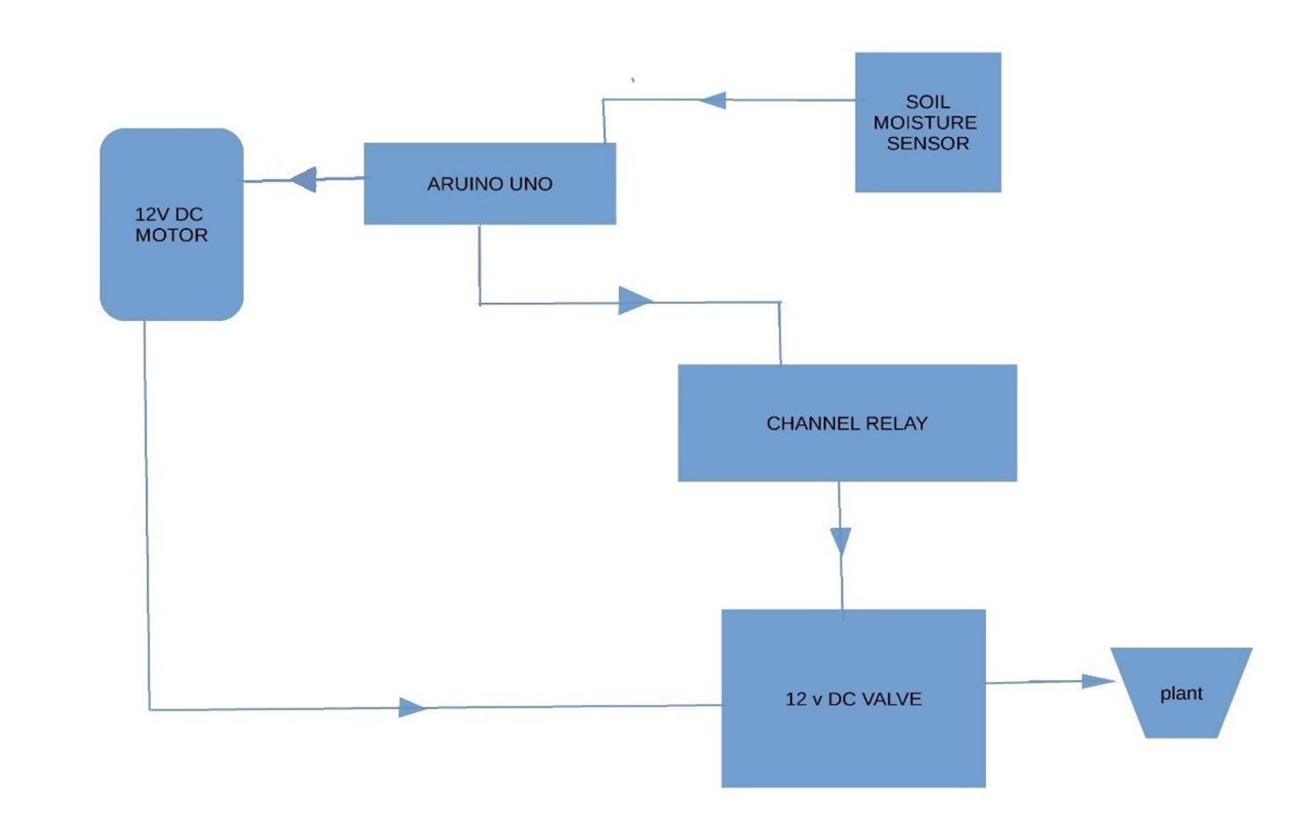

Block Diagram of Automatic Plant Watering Machine.

**4.3 DESIGN DESCRIPTION:**

In our project, Firstly, Arduino UNO board, relay module, power supply and moisture sensor are setup on the board.

Then relay module and Arduino UNO board are connected to respective pins,Moisture sensor is also connected to the UNO board to sense the water content of the plant. According to code, the soil sensor pins are connected to the aurdino UNO with the help of breadboard .The solenoid valves are connected to the relay and the water pump is connected to the Arduino UNO board. So that we can control the waterflow through the pipe and allow the water to go through respective according to the given connections.

Measurement of the soil moisture is done by the soil moisture sensor. By insering the soil sensor into the soil , we can get input from the soil sensor which forwards the information and parameters regarding the soil moisture to the micro controller. Using aurdino uno we can write the code and give the pin connection between moisture sensor and aurdinowhich controls the water pumps.

Relay module is connected to aurdino and solenoid valve with which the plants can get water according to the given input by the moisture sensor.

If the soil moisture decreases below certain value, the micro controller sends the signal to relay module which will open the solenoid valve also runs the water pump untill certain amount of water is released.

**5.IMPLEMENTATION:**

**5.1 RESULTS AND DISSCUSSION:**

The automatic plant watering can be used in the following areas:

1. home nursery

2. plant nursery

By using our automatic plant watering machine, many of us can save time and plants may not die due to over watering or forget to watering . This will make our life easier and once bought will remain for life long.

**5.2 CONCLUSION:**

Here by we conclude that our automatic plant watering machine is a tool that helps in watering the plants which are in huge quantity without any humans required . The automatic plant watering machine is less in cost and can be used in home and plant nursery. It is portable.

**6.1. APPENDIX:**

<https://www.google.com/search?q=manual+watering+to+plants&rlz=1C1JZAP_enIN903IN903&sxsrf=ALeKk02hUYhkSClNNFs3kKz6kRel7e_P2w:1611718808516&source=lnms&tbm=isch&sa=X&ved=2ahUKEwjQvby4mLvuAhWiH7cAHdQMDdUQ_AUoAXoECBoQAw&biw=1522&bih=706#imgrc=jBEUHLKHe-lQYM>

<https://www.google.com/search?q=automatic+plant+watering+system+using+soil+moisture+sensor&rlz=1C1JZAP_enIN903IN903&sxsrf=ALeKk03SdhRPh7TsArL_JLvSi0Fiq_rkkA:1611718994098&source=lnms&tbm=isch&sa=X&ved=2ahUKEwjnuPuQmbvuAhVDIbcAHUVlB68Q_AUoAXoECBkQAw&biw=1522&bih=706&dpr=1.25#imgrc=0aGkhF3VhuyvHM>

**6.2. REFERENCES:**

[1] https://components101.com/ microcontrollers/ arduino-uno

[2] <http://www.circuitbasics.com/setting-up-a-5v-relay-on-the-arduino/>

[3] https://vigyanashram.files.wordpress.com/ 2015/05/

[4] <https://learn.sparkfun.com/tutorials/installing-arduino-ide/all.pdf>

[5] [14 Dez] Devika et al., International Journal of Advanced Research in Computer Science and Software Engineering 4(10), October - 2014, pp. 449-456

[6] [16 San] Sandeep K. Shukla, IIT Kanpur, Introduction to embedded system, Aug 29, 2016

[7] [16 SHA] SHAIKH SHEROZ MOHD HASAN, ‘AUTO IRRIGATION USING ARDUINIO’2016

[8] N.Đuzić and D. Đumić: Automatic Plant Watering System and its Applications, Coll.Antropol

**Code :**

int sensor1 = 2;

int sensor2 = 3;

int sensor3 = 4;

int sensor4 = 5;

int relay1 = 6;

int relay2 = 7;

int relay3 = 8;

int relay4 = 9;

int val1,val2,val3,val4;

void setup() {

pinMode(relay1,OUTPUT);

pinMode(sensor1,INPUT);

pinMode(relay2,OUTPUT);

pinMode(sensor2,INPUT);

pinMode(relay3,OUTPUT);

pinMode(sensor3,INPUT);

pinMode(relay4, OUTPUT);

pinMode(sensor4,INPUT);

}

void loop() {

val1 = digitalRead(sensor1);

if(val1 == LOW)

{

digitalWrite(relay1,HIGH);

}

else

{

digitalWrite(relay1,LOW);

}

val2 = digitalRead(sensor2);

if(val2 == LOW){

digitalWrite(relay2,HIGH);

}

else{

digitalWrite(relay2,LOW);

}

val3 = digitalRead(sensor3);

if(val3 == LOW)

{

digitalWrite(relay3,HIGH);

}

else

{

digitalWrite(relay3,LOW);

}

val4 = digitalRead(sensor4);

if(val4 == LOW)

{

digitalWrite(relay4,HIGH);

}

else

{

digitalWrite(relay4,LOW);

}

}